NCR Corporate Remittance Solution
Scope of Work


MAY YOU HAVE ANY QUESTIONS OR INQUIRIES IN THIS DOCUMENT,
PLEASE LET ME KNOW...

Submitted to:


Contents
Non-Disclosure Terms & Conditions 2
1. Executive Summary 3
2. Payment & Project Expenses 4
3. Proposed System Architecture 4
3.1 Upload Flow 5
3.2 Display Status/Cancel Transaction Flow 11
3.3 Check Registration Flow 15
3.4 Registration Flow 19
3.5 ATM Flow 23
3.6 Work Flow 24
4. Reports 25
5. System Requirements 26
6. Proposed Migration Plan 27
7. Acceptance Criteria 27
Appendix A 28
Statement of Work 28
EXHIBIT A-1 31
EXHIBIT A-2 32
EXHIBIT B-1 33
EXHIBIT B-2 34

Non-Disclosure Terms & Conditions

This document includes data that shall not be disclosed outside of BANQUE MISR and shall not be duplicated, used, or disclosed in whole, or in part, for any purpose other than to evaluate this document. If, however, a contract is awarded to this offer as a result of, or in connection with, the submission of this data, BANQUE MISR shall have the right to duplicate, use, or disclose the data to the extent provided in the resulting contract. This restriction does not limit BANQUE MISR right to use information contained in this data if it is obtained from another source without restriction.

The material in this document (relating to NCR equipment, partner equipment, programs, products, and services) is to be treated as confidential and a trade secret of NCR. Information is not to be used or disclosed except to the recipient’s employees, and officers engaged in evaluating this document, and who are subject to appropriate written undertakings consistent with this confidentiality and use restrictions.

Every effort has been made to identify trademark information in the accompanying text. However, this information may unintentionally have been omitted in referencing particular products. Product names that are not noted may also be registered trademarks or trademarks of their respective holders.
Copyright © 2013 by NCR. All Rights Reserved. Confidential, Unpublished Property of NCR.

Executive Summary
This document to illustrate how the corporate customer will use the enhanced remittance solution to upload one to many transactions using bank web portal

Payment & Project Expenses
PO to be submitted once the scope approved by the bank business team

Proposed System Architecture

NCR Corporate Remittance Solution One-To-Many Transfers

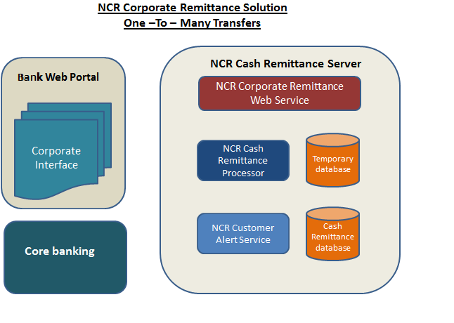

Upload Flow
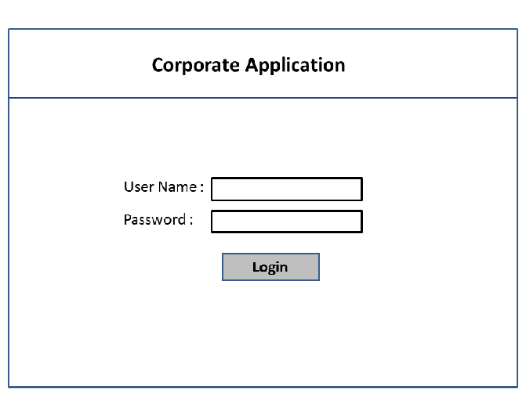
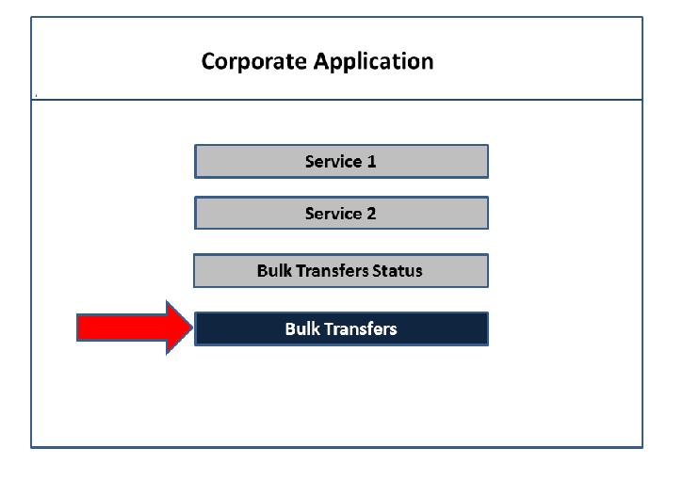
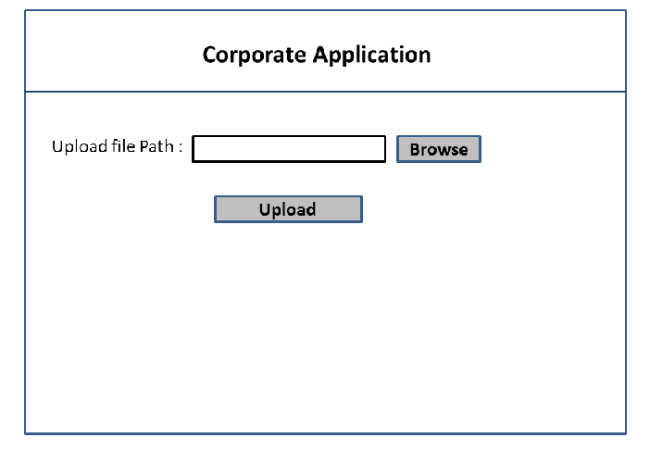

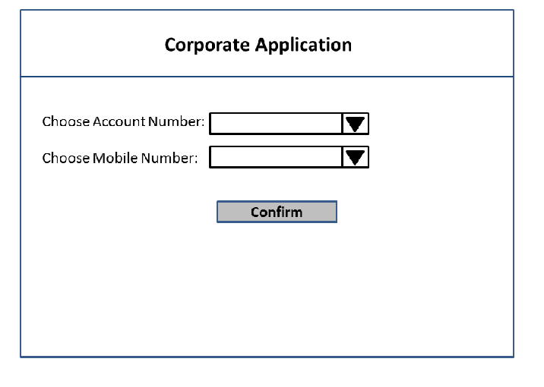

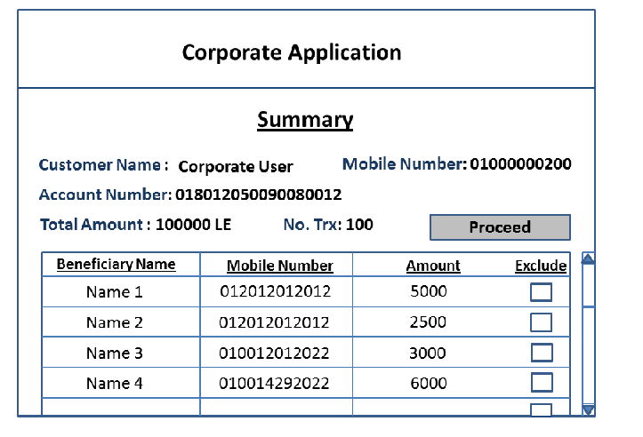

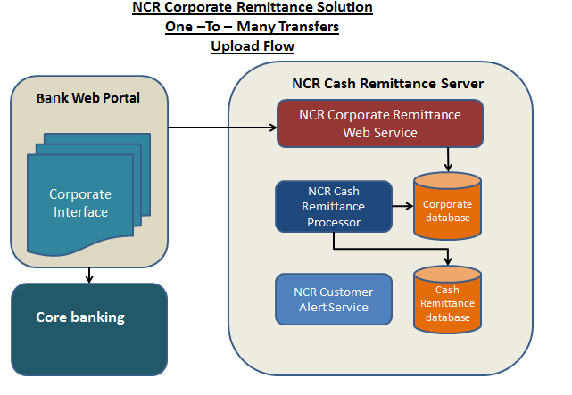
Upload Flow:
- BANQUE MISR Portal will send Transactions in XML format to NCR Corporate Web Service.
- NCR Corporate Web Service will insert transactions in Corporate Database and revert back to BANQUE MISR Portal.
- NCR Cash Remittance Processor will loop on each transaction to validate and create remittance transaction.
- NCR Customer alert will send SMSs to depositor and beneficiaries.

Display Status/Cancel Transaction Flow
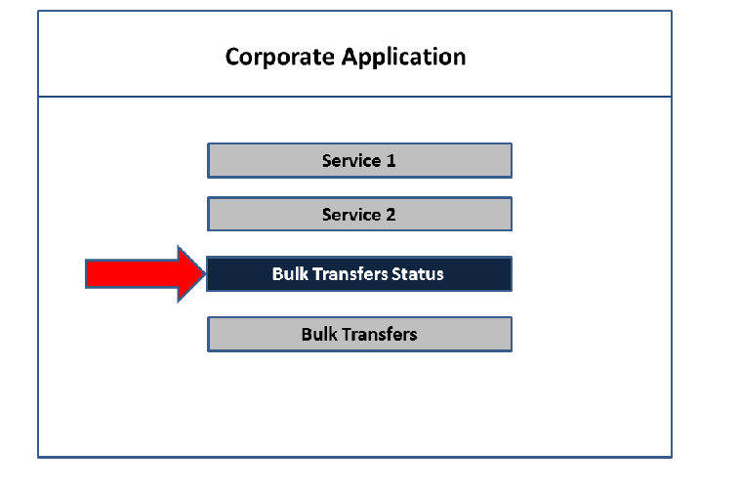
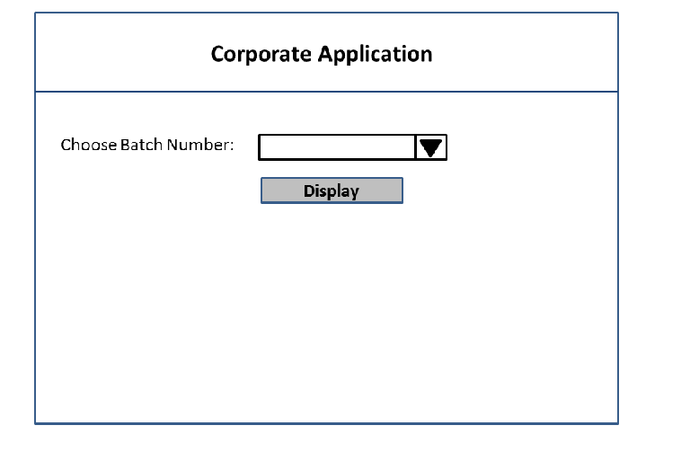
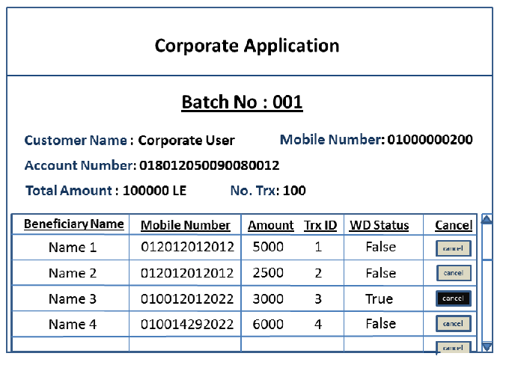

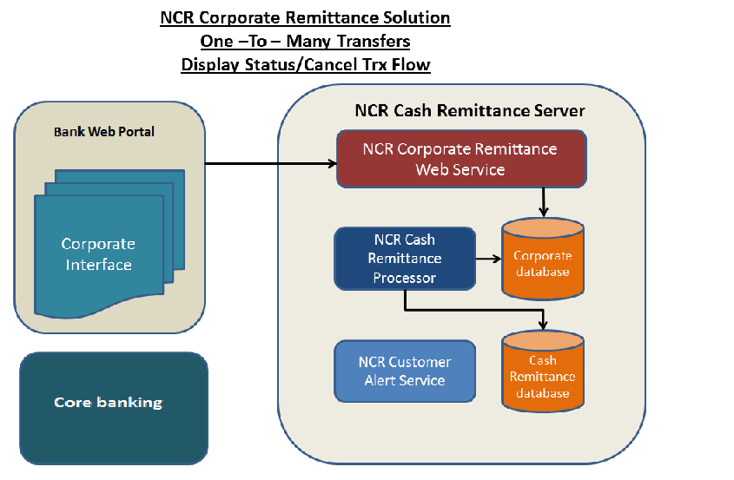
Display Status Flow
- User Will choose which batch want to be displayed
- BANQUE MISR Portal will send chosen Transaction Ids to NCR Corporate Web Service Transaction
- NCR Corporate Web Service will return the transaction details for the chosen Transactions.
- BANQUE MISR Portal will enable cancel button for each transaction if the Withdrawal status equal false.
- User can choose to cancel a specific transaction.
  - BANQUE MISR Portal will send cancel request to NCR Corporate Web Service
  - NCR Cash Remittance Processor will update transaction cancel status
  - NCR Customer Alert Service will send message to depositor that the transaction is canceled

Check Registration Flow

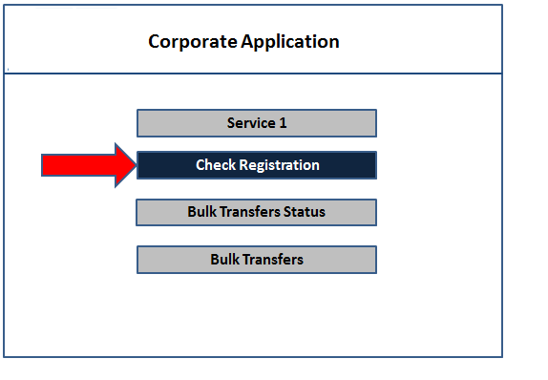

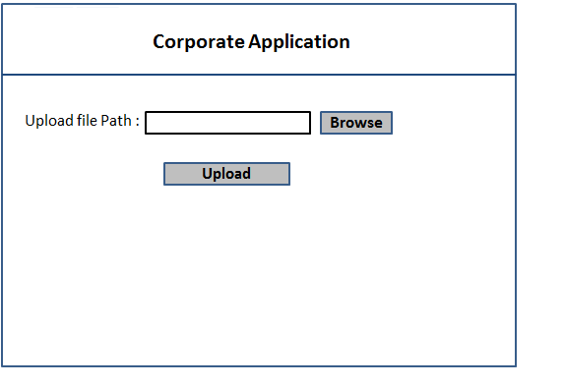

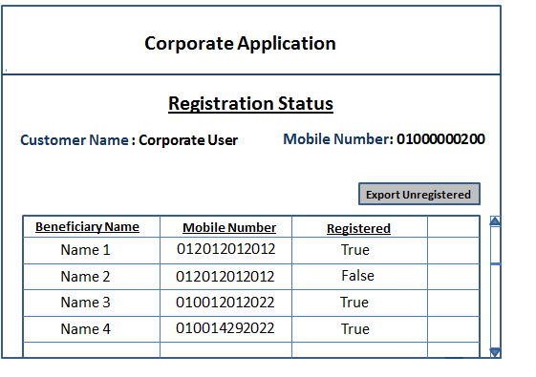

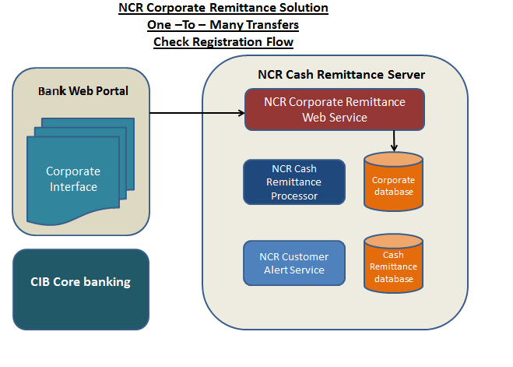
Check Registration Flow
- BANQUE MISR Portal will send beneficiaries Mobile Number in XML format to NCR Corporate Web Service.
- NCR Corporate Web Service will check mobile registration for each beneficiary sent by BANQUE MISR Portal.
- NCR Corporate Web Service will return with the registration status.
- BANQUE MISR Portal will display the Registration status
- BANQUE MISR Portal will enable export feature to export the unregistered beneficiaries to a file.

Registration Flow

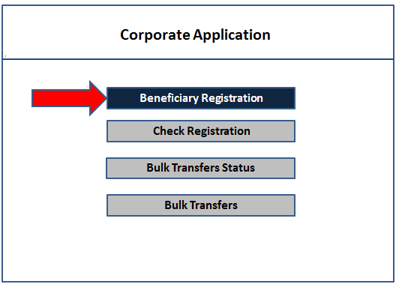

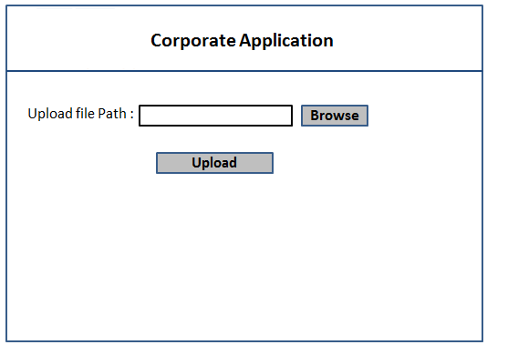

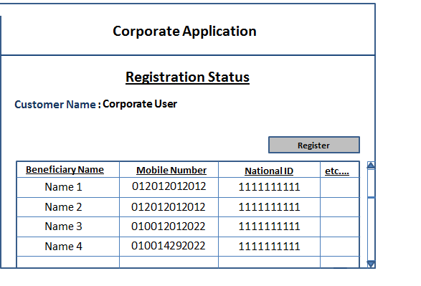

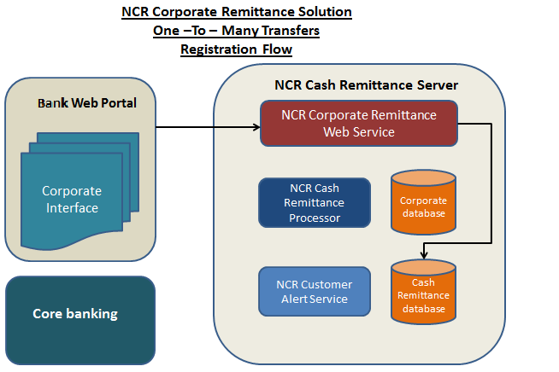

Registration Flow
- BANQUE MISR Portal will send beneficiaries’ details in XML format to NCR Corporate Web Service.
- NCR Corporate Web Service will add the new beneficiary details to Cash remittance database
- NCR Corporate Web Service will return with the status of insertion.

ATM Flow
NCR Corporate Remittance Solution
One –To – Many Transfers
ATM Flow
Corporate Remittance
Cardless Menu
Please Select a Service
Cash Remittance
Please Enter PIN
****
1
2
3
4
5
6
7
8
9
0
Please Enter Your
Mobile Number
01282450
1
2
3
4
5
6
7
8
9
0
Please Enter Amount
1000
1
2
3
4
5
6
7
8
9
0
Please Take Your Money
$
Please Take Your Receipt
Thanks For Using This Service
......................
1
2
3
6
5
4

Work Flow

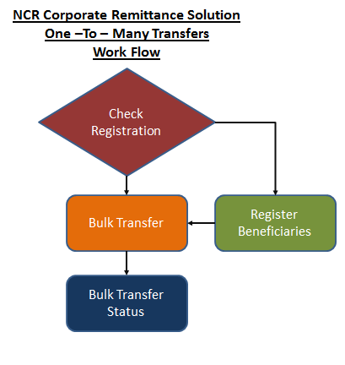
- User will choose to check beneficiaries’ registration
  - If there are unregistered beneficiaries
    - user will export unregistered beneficiaries to a file
    - User will complete all necessary details about each unregistered beneficiary in the exported file.
    - User will upload the registration file then proceed.
- User will choose bulk transfer
- User will check payment status

Reports
- Registered Customers
  - Mobile number
  - Customer Name
  - National ID
  - Registration Date
  - Address
  - User Name
  - Registration Channel
  - Branch Name
- Cash Withdrawal /Redemption transaction:
  - Beneficiary Mobile Number
  - Amount
  - ATM ID
  - ATM Location
  - Transaction Date
  - Transaction Time
  - Transaction Initiation Channel (Corporate Remittance)
  - Depositor Mobile Number
- Cash Deposit transaction:
  - Initiator Mobile Number
  - Amount
  - ATM ID
  - ATM Location
  - Transaction Date
  - Transaction Time
  - Transaction Initiation Channel (Corporate Remittance)
  - Beneficiary Mobile Number

- Statistical Data
  - Total Transactions (Search Identifier is Data From-To):
    - Number of Registered customers
    - Number of deposits transactions
    - Number of Withdrawal transactions
    - Number of Redemption
  - Customer (Search Identifier is Mobile Number):
    - Number of deposits transactions
    - Number of withdrawal transactions
    - Number of Redemption

System Requirements
Application Server
Computer and processor | Server with Intel Xeon 3.0 GHz+
Memory | 8 GB RAM+
Hard disk Storage | 200 GB+
OS | Windows Server 2012
Web Server | IIS 7.5
Database Server
Computer and processor | Server with Intel Xeon 3.0 GHz+
Memory | 4 GB RAM+
Hard disk Storage | 200 GB+
OS | Windows Server 2012
Database Engine | MS SQL Server 2012

Proposed Migration Plan
Project Plan will be submitted once the Scope & PO Approved by bank team.

Acceptance Criteria
The project is to be considered as implemented and accepted upon completing the testing scenarios by the bank and signing-off the User Acceptance Test Form in Appendix C & move to production.
Any additional requirements not mentioned previously in the scope of work, should be requested by BANQUE MISR and NCR has the right to evaluate this request and charge BANQUE MISR accordingly.

Appendix A

Statement of Work

The following constitutes the Statement of Work between (BANQUE MISR) and NCR Egypt (NCR) for contractual services provided to BANQUE MISR for project name. Neither NCR, nor those acting on its behalf, will be liable for any decisions made by BANQUE MISR or those acting on their behalf in the development of any systems, products, or software solutions, unless NCR accepts such decision in writing.
1.0 Scope
The scope of the project covers the project management and the technical services that will be provided to implement the following.
1. Application installation
2. Application setup & configuration
3. Live production setup
2.0 Term
Service delivery will begin after the date of the sign-off this document, The Start Date and/or End Date may be delayed due to delays in executing this Statement of Work, availability of required hardware and software, availability of the bank personnel, or changes to the Project Scope or functional specification. Changes in the Project Scope or functional specification may result in additional charges and/or delay in meeting the original project end date.
3.0 Personnel
3.1 NCR Project Manager - NCR will appoint a Project Manager who will be responsible for overall management of NCR’s (and NCR’s contractors) activities of the project. The Project Manager will work with NCR and BANQUE MISR personnel to accomplish the tasks outlined in this Statement of Work, manage day-to-day project activities, and serve as NCR's single point of contact with respect to interfacing with BANQUE MISR.
3.2 BANQUE MISR Project Manager – BANQUE MISR will designate a Project Manager who will be regularly available to meet with BANQUE MISR and NCR personnel on matters pertaining to this project. This individual will procure, manage and direct the bank’s resources as requested by NCR Project Manager and as defined in this Statement

of Work. BANQUE MISR Project Manager will serve as the bank’s single point of contact when interfacing with NCR regarding the project scope described by this Statement of Work.
3.3 NCR Resources - NCR will, in its sole discretion, determine the number of personnel, and the appropriate skill sets, necessary to complete this project.
NCR has identified initial resource levels for this project; such levels are subject to change by NCR:
· Integration consultant
· Software consultant
· ATM consultant
3.4 BANQUE MISR Resources – BANQUE MISR agrees to appoint the required resources to this Project. BANQUE MISR acknowledges that these resources are necessary if the project is to be completed in the time.

4.0 NCR Responsibilities

4.1 To identify the specifications of the required HW and SW environment.
4.2 To install and implement the modules that described in the project scope
4.3 To conduct Project Updates with BANQUE MISR
4.4 To develop Implementation time schedule showing the implementation phases

5.0 BANQUE MISR Responsibilities

5.1 To avail the HW and the SW as per the advised specification by NCR.
5.2 To integrate with NCR from core banking application side, for the card based transactions.
5.3 To conduct the required User Acceptance Test.
5.4 To sign-off the acceptance certificate.

6.0 Deliverables

6.1 Implementation time schedule showing the implementation phases
6.2 installation & implementation of the modules that described in the project scope

7.0 Change Control Process

7.1 The Change Control Process governs changes to the project scope during the life of the project. The purpose of this process is to standardize and optimize the evaluation,

testing, and installation of any new features and functionalities during the project. The process will be applied to new components and to enhancements of existing

components. The Change Control Process will commence at the start of the project and will continue throughout the project's duration. Additional procedures and responsibilities may be outlined by the Project Manager, mutually accepted by both NCR and BANQUE MISR Project Manager, and included in the baseline project plan.

7.2 A Change Request substantially in the form will be to NCR for communicating any desired changes to the project. It will describe the change, the reason for the change, and the effect the change may have on the project. The Project Manager of the requesting party will submit a written Change Request to the Project Manager for the other party. The other party will formulate an initial response.

7.3 Both NCR and BANQUE MISR will review the proposed Change Request and approve it for further study or reject it. The costs for the study, if any, will be agreed upon by both NCR and BANQUE MISR. If the study is agreed to, both NCR and BANQUE MISR will sign the Change Request. This approves only the study and its related costs. The results of the study will be used to determine the effect that the implementation of the Change Request will have on the cost and schedule of the project.

7.4 Both NCR and BANQUE MISR must sign the approval portion of the Change Request to authorize the implementation of any change that affects the Project’s scope, schedule, or price.

8.0 Acceptance Criteria

The project will be considered accepted upon final acceptance (Appendix A) or going live.

9.0 Order of Precedence

This Sow, together with its appendixes states all of the rights and responsibilities of, and supersedes all prior oral and written communications, between NCR and BANQUE MISR regarding this project.
Agreed and Accepted: BANQUE MISR | NCR
By: | By:
Printed Name | Printed Name: Ahmed Fahmy
Title: | Title: SW Project Manager
Date: | Date:

EXHIBIT A-1
UAT Certificate

Customer  Customer ID: | Please write The BANQUE MISR  Please write The bank ID
Project ID:  Project Name: | Please write your signature here  NCR Corporate Remittance Solution
Date: | Please write the date here

This is to certify that NCR Corporate Remittance solution has been accepted & signed off by bank team.

Signed by:
Title:
Signature:
Date: | DD/MM/YYYY

EXHIBIT A-2
Acceptance Certificate

Customer  Customer ID: | Please write The BANQUE MISR  Please write The bank ID
Project ID:  Project Name: | Please write your signature here  NCR Corporate Remittance Solution
Date: | Please write the date here

This is to certify that the above project has been accepted

Signed by:
Title:
Signature:
Date: | DD/MM/YYYY

EXHIBIT B-1
CHANGE REQUEST FORM
Requestor Name | Please write your name here
Requestor Title: | Please write your title here
Requestor Signature: | Please write your signature here
Date: | Please write the date here

REQUESTED CHANGE
__________________________________________________________________________________________________________________________________________________________________________________________________________________________________________________________________________________________________________________________________________________________________________________________________________________________.

ESTIMATED IMPACT
_______________________________________________________________________________________________________________________________________________________________________________________________________________________________________________________________________________________________________________________________________________________________________________________________________________________________________________________________________________________________________________________________________.

- Change Request Received
By
Title
Change Request No.

EXHIBIT B-2
CHANGE REQUEST RESPONSE
Requestor Name | Please write your name here
Requestor Title: | Please write your title here

CHANGE REQUEST
 | Approved |  |  |  | Not Approved

Approval / Non Approval Reason
_______________________________________________________________________________________________________________________________________________________________________________________________________________________________________________________________________________________________________________________________________________________________________________________________________________________________________________________________________________________________________________________________________.

ESTIMATED COST IMPACT
_______________________________________________________________________________________________________________________________________________________________________________________________________________________________________________________________________________________________________________________________________________________________________________________________________________________________________________________________________________________________________________________________________.

- Response approved by
By
Title
Change Request No.

